Verendrye Museum, Inc.
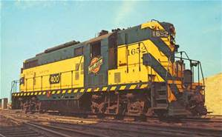
P. O. Box 665
Fort Pierre, SD 57532

TRACKS OF TIME
****Historic Fort Pierre Railroad Depot Commemorative Brick Application****
Be a part of Fort Pierre’s history. Your personalized engraved commemorative brick will be placed on the platform of the rehabilitated railroad depot. Your venture ensures your name in history and supports the Verendrye Museum.
If you would like a commemorative brick engraved with your name or family information, please fill out this form. The cost will be $54.00 per brick (tax included). You may use 1, 2, or 3 lines. Make check payable to the Verendrye Museum and mail both check and application to Box 665, Fort Pierre, SD. 57532
Name: __________________________________________________
Address:________________________________________________
_________________________________________________
Phone Number: Home: __________________ Cell:________________
E-mail address:_______________________________Date____________
Fill in the information you want engraved, using one box per letter. You must allow a space between words. Make checks payable to Verendrye Museum.
1st

2nd

3rd

